

**RAGHU ENGINEERING COLLEGE**

**Permanently Affiliated to JNTUK, Approved by AICTEAccredited by NBA Accredited by NAAC with A grade**

**Ranked AAA by Careers 360Ranked A Grade by AP State Knowledge MissionRanked 63rd among Top 100 Private Engineering Colleges in India**

**by Higher Education Review Magazine.**

**Ranked 92nd among top private Engineering colleges in India**

**by the Week MagazineRanked 14th among 33 promising Engineering Colleges in India by GHRD**

[**www.raghuenggcollege.com**](http://www.raghuenggcollege.com)

**Department of Mechanical Engineering**

**IV B.Tech I Semester**

**FINITE ELEMENT METHODS**

**UNIT-III**

**Day - 17**

**Concepts Covered:**Analysis of Trusses: Finite Element Modeling, Co-Ordinates & Shape Functions.

**1.What is a Truss? Give its Classification.**

**Ans:**

A Truss is a two force members made up of bars that are connected at the ends by joints. Every stress element is in either tension or compression. Trusses cam be classified as plane truss and space truss.

* Plane truss is one where the plane of the structure remain in plane even after the application of loads.
* While space truss plane will not be in a same plane.



Fig 3.1 Truss bar element

Fig. shows 2d truss structure and each node has two degrees of freedom. The only difference between bar element and truss element is that in bars both local and global coordinate systems are same where as in truss these are different.

In a truss, it is required that all loads and reactions are applied only at the joints and that all members are connected together at their ends by frictionless pin joints. The finite element method on the other hand is applicable to statically determinate or indeterminate structures alike. The finite element method also provides joint deflections. Effects of temperature changes and support settlements can also be routinely bandied.

**2.What are the assumptions for a Truss Element?**

**Ans:**

There are always assumptions associated with every finite element analysis. If all the assumptions below are all valid for a given situation, then truss element will yield an exact solution. Some of the assumptions are:

* Truss element is only a prismatic member ie cross sectional area is uniform along its length
* It should be a isotropic material
* Constant load i.e, load is independent of time
* Homogenous material
* A load on a truss can only be applied at its joints (nodes)
* Due to the load applied each bar of a truss is either induced with tensile/compressive forces
* The joints in a truss are assumed to be frictionless pin joints
* Self weight of the bars is neglected

**Classwork:**

1. Write short notes on Trusses.
2. What are the assumptions of truss element.

**Homework:**

1. Explain about Truss Element. Give its assumptions.
2. List out the applications of truss element

**Day - 18**

**Concepts Covered:** Assembly of Global Stiffness Matrix and Load Vector.

**1.Derive the stiffness matrix of a truss element.**

**Ans:**

Consider a pin jointed bar element as shown in fig, for truss analysis

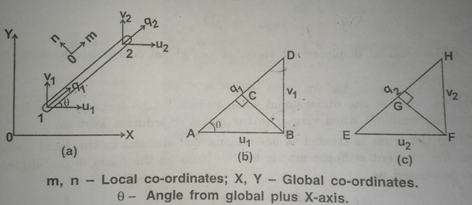

Fig 3.2

Let q1, q2 – displacements of the nodes 1 and 2 along the element axis

u1, v1 and u2, v2 – components of displacements q1 and q2

From fig (b) and (c) we get

q1 = AC + CD = AB cosθ + BD sinθ = u1 cosθ + v1 sinθ

q2 = EG + GH = EF cosθ + FH sinθ = u2 cosθ + v2 sinθ ---------(1)

Write in the matrix form we get

----------(2)

Let C = cosθ, S = sinθ

Then

Strain energy U = * nodal force * corresponding displacement

U = (P1q1 + P2q2)

U = [ P1 P2] ------------(3)

U = T

For a bar element =

U = * T

U = T

U = T

U = { u12 + v12 +u22 +v2 2 }

U = { u12 + v12 +u22 +v2 2 }

According to castiglineos I theorem

= Fi

{ F } = [ K ] { u }

Stiffness matrix [ K ] =

**Class work:**

1. Derive the global stiffness matrix for a truss element.

**Homework:**

1. Explain the concept of Global Stiffness Matrix and Load Vector.

**Important and Previous JNTUK Questions:**

1. Derive the stiffness matrix of a truss element. (Nov 2015, 8M)
2. How many DOFs does a two-nodal, planar truss element have in its local coordinate system, and in the global coordinate system? Why is there a difference in DOFs in these two coordinate systems? (JUN 2015, 15M)

**Day - 19**

**Concepts Covered:** Finite Element Equations and Treatment of Boundary Conditions Stress, Strain and Support Reaction Calculations.

**1.Write the expressions for calculations of stresses for truss element.**

**Ans:**

Expressions for the element stresses can be obtained by observing that a truss element in local coordinates is a simple two force element as shown in fig.

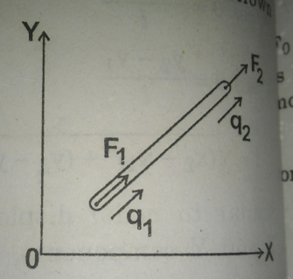

Fig 3.3

The stress induced in a truss element is given by

σ = E e

σ = =

σ =

The above expression can be written in terms of global coordinate system

{ q } = [ L ] { δ }

σ = ------------(1)

σ =

**2.Write the expressions for temperature effects on truss bar element**

**Ans:**

When the truss is subjected to a change of temperature, the force developed due to change of temperature, called as thermal force, must be taken into account during the determination of nodal displacements.

Consider a truss shown in fig.

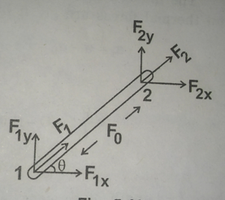

Fig 3.4 truss element

Let,

F1, F2 - externally applied loads called as nodal forces at nodes nodes 1 and 2

F1x, F1y – X and Y components of F1

F2x, F2y - X and Y components of F2

Now, F1x = F1 cosθ, F1y = F1sinθ ;

F2x = F2 cosθ, F2y = F2sinθ ;

When the element is undergoing change in temperature,

Thermal force F0 = EAαΔT

Where,

α - coefficient of thermal expansion or contraction

ΔT – change of temperature

A – area of cross section of truss

E – modulus of elasticity

Thermal force at nodes 1 and 2 will be specified as

{ F0 } = =

Let,

F01x, F01y – X and Y components of F01

F02x, F02y - X and Y components of F02

The resultant forces at nodes 1 and 2 in X and Y directions are given by

=

The induced resultant stresses for the truss element subjected to point loadand thermal forces are given by

σr = σ - σ0

σr = Ee – E α ΔT

σr = – E α ΔT

Where,

L – length of the element

C = cosθ , S = sinθ

**Class work:**

1.Derive the expressions for calculations of stresses for truss element.

2.Derive the expressions for temperature effects on truss bar element.

**Home work:**

1.Write the expressions for calculations of stresses for truss element.

2.Write the expressions for temperature effects on truss bar element.

**Day - 20**

**Concepts Covered: Problems**

**Problem 1:**

**1.A truss structure is subjected to a load of 1KN as shown in fig. Calculate nodal displacements and forces if the element stiffness of the truss is 10KN/mm.**

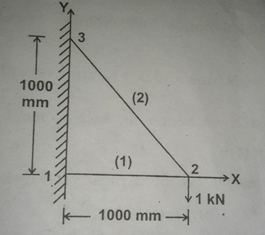

**Fig 3.5 Two bar truss**

**Ans:**

**Given data:**

K1 = = 10kN/mm = 10000N/mm

K2 = = 10kN/mm = 10000N/mm

F = - 1kN = -1000N

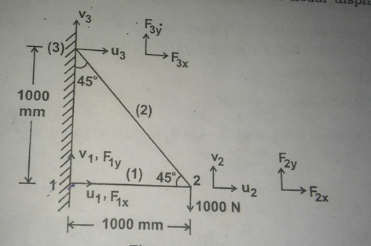

Fig 3.6 Truss structure with nodal displacements and forces

Let,

u1, v1, u2, v2, u3, v3 – displacements at nodes 1, 2, 3 along X aannd Y axes.

F1x , F1y , F2x , F2y , F3x , F3y - Nodal forces along the axes X and Y at nodes 1, 2, 3

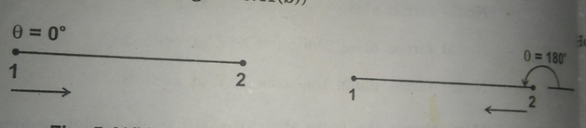

Fig 3.7 To find angles

Element connectivity table

|  |  |  |  |
| --- | --- | --- | --- |
| Element | Nodes | Cos θ | Sin θ |
| 1 | 1 and 2 | Cos 0 = 1 | Sin 0 = 0 |
| 2 | 2 and 3 | Cos 135 = - 0.707 | Sin 135 = 0.707 |

**Stiffness matrix:**

Stiffness matrix for element 1

[ K1 ] =

θ = 0°,cosθ = cos0 = 1, sinθ = sin0 = 0

[ K1 ] =

Stiffness matrix for element 2

[ K2 ] =

θ = 135°,cosθ = cos135 = - 707, sinθ = sin135 = 707

[ K1 ] =

Global stiffness matrix [ K ] = [ K1 ] + [ K2 ]

[ K ] =

Finite element equation is given by { F } = [ K ] { δ }

Since nodes 1 and 3 are fixed, u1 = v1= u3 = v3 = 0

Eliminate 1st, 2nd , 5th , 6th rows and columns we get

1.5u2 - 0.5v2 = 0

-0.5u2 + 0.5v2 = -1000

Solving the above equations we get

**u2 = - 0.1mm**

**v2 = - 0.3mm**

**Reaction forces:**

F1x = 10000(-1u2) = 10000[ (-1)(-0.1) ] = **1000N**

F1y = **0**

F3x = 10000[-0.5u2+0.5v2] = 10000[ (-0.5)(-0.1) + 0.5(-0.3) ] = **-1000N**

F3y = 10000[ 0.5u2-0.5v2 ] = 10000[ 0.5(-0.1) – 0.5 (-0.3) ] = **1000N**

**Result:**

**The nodal displacements are u1 = 0, v1 = 0, u2 = - 0.1mm , v2 = -0.3mm, u3 = 0, v3 = 0**

**The nodal forces are**

**F1x = 1000N , F1y = 0;**

**F2x = 0, F2y = -1000N;**

**F3x = -1000N, F3y = 1000N**

**Class work:**

**1.A truss structure is subjected to a load of 1KN as shown in fig. Calculate nodal displacements and forces if the element stiffness of the truss is 10KN/mm.**



**Fig 3.8 Two bar truss**

**Home work:**

1. **The loading and other parameters for a two bar truss element is shown in fig. Determine**

**(a) Element stiffness matrix for each element**

**(b) global stiffness matrix**

**(c) nodal displacements**

**(d)reaction forces**

**(e) stresses induced in the elements. Assume E = 200GPa.**

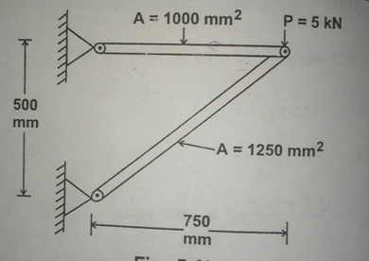

**Fig 3.9 Two bar truss**

**Important and Previous JNTUK Questions:**

1. A small railroad bridge is constructed of steel members, all of which have a cross-sectional area of 3250 mm2.A train stops on the bridge., and the loads applied to the truss on one side of the bridge are as shown in Fig. Estimate how much the point *R* moves horizontally because of this loading. Also determine the nodal displacements and element stresses. (Nov 2012, 15M)

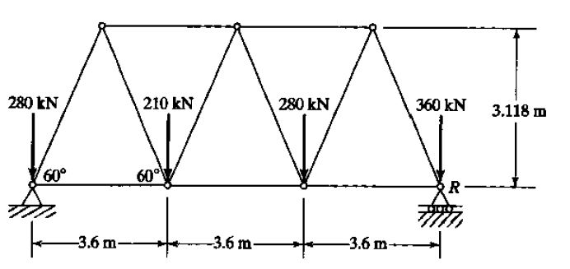

Fig 3.10

**Note:** By considering the above information, solve the following figure.

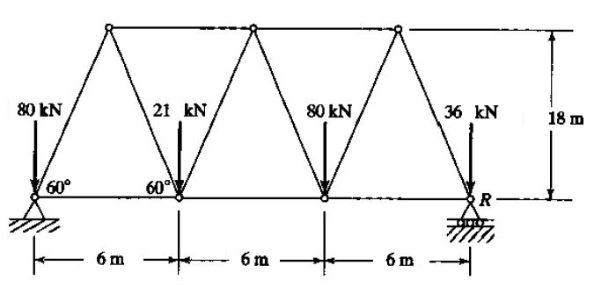

Fig 3.11

**Day 21,22**

**Concepts covered: Problems**

**1.Determine the nodal displacements, support reactions and element stresses for a three member pinned truss as shown in fig. The members are made of steel material having properties**

**E = 20*106 N/cm 2 and α = 11*10-6cm/cm°C. The truss experiences a rise in temperature of 5°C. A 100KN load is applied as shown in fig.**

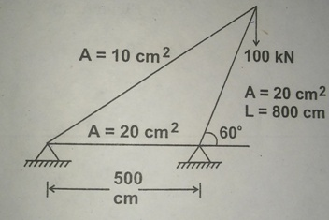

**Fig 3.12 A three member truss**

**Ans:**

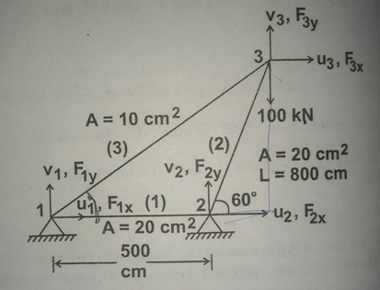

**Fig 3.13**

**Given data:**

A1 = 20cm2 A2 = 20cm2  A3 = 10cm2

L1 = 500cm L2 = 800cm L3 = 1136cm

E1 = E2 = E3 = 20*106N/cm 2

α1 = α2 = α3 = 11*10-6cm/cm°C

ΔT = 5°c

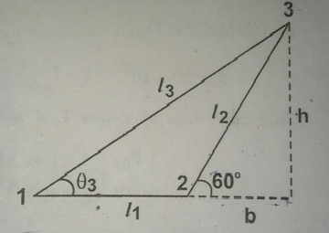

Fig 3.14

h = L2 sin60 = 800sin60 = 693cm

b = L2 cos60 = 800cos60 = 400cm

L3 = = = 1136cm

Element connectivity table

|  |  |  |  |
| --- | --- | --- | --- |
| Element | Nodes | cosθ | sinθ |
| 1 | 1 and 2 | Cos 0 = 1 | Sin 0 = 0 |
| 2 | 2 and 3 | Cos 60 = 0.5 | Sin 60 = 0.866 |
| 3 | 1 and 3 | Cos 37.6 = 0.792 | Sin 37.6 = 0.61 |

Explanation for θ values for element 3 will be explained at element 3

**Stiffness matrix:**

Stiffness matrix for element 1

[ K1 ] =

= = 8*105N/cm

1 = 0 (measuring at node 1)

Cos 0 = 1 , sin 0 = 0

[ K1 ] = 8*105 = 105

Stiffness matrix for element 2

[ K2 ] =

= = 5*105 N/cm

2 = 60

= 0.5, sin 60 = 0.866

[ K2 ] =

[ K2 ] = 5*105

[ K2 ] = 105

Stiffness matrix for element 3

[ K3 ] =

= = 1.76*105

3  can be measured at node 1

= = = 0.77

3  = = 37.6°

= 0.792 , sin 37.6 = 0.61

[ K3 ] = 1.76*105

[ K3 ] = 105

Global stiffness matrix [ K ] = [ K1 ] + [ K2 ] + [ K3 ]

[ K ] =105*

**Thermal force vectors:**

For element 1

F0(1) = (A E α ΔT)1

F0(1) = 20*20*106 *11*10 -6*5 = 22000N

Thermal forces at nodes 1 and 2 acting along the axis of the element 1

= = N

The X and Y components are,

= = N

For element 2

F0(2) = (A E α ΔT)2

F0(2) = 20*20*106 *11*10 -6*5 = 22000N

Thermal forces at nodes 1 and 2 acting along the axis of the element 1

= = N

The X and Y components are,

= = N

For element 3

F0(3) = (A E α ΔT)3

F0(3) = 10*20*106 *11*10 -6*5 = 11000N

Thermal forces at nodes 1 and 2 acting along the axis of the element 1

= = N

The X and Y components are,

= = N

In each node, since both point loads and thermal forces are acting, the resultant nodal forces acting at any node is the algebraic sum of both point loads and thermal forces.

The resultant nodal forces at nodes 1, 2, 3 in X and Y directions are given by

= = =

F1x, F1y, F2x, F2y act as reaction forces

Finite element equation for truss structure can be written as

[ K]{ δ } = [ F ]

105* =

Since nodes 1 and 2 are fixed ,

u1 = 0, v1 =0,u2 = 0, v2 = 0

105*

105[2.36u3+3.005v3] = 19715

105[3.005u3+4.4v3] = -74235

Solving the above equations we get

u3 = 2.27cm

v3 = - 1.72cm

= 105 [ -1.11u3 - 0.84v3] = 105 [ -1.11*2.27 - 0.84*- 1.72] = -76775 N

= 105 [ - 0.84u3 – 0.65v3] = 105 [ -8.84*2.27 - 0.65*- 1.72] = -78880 N

= 105 [ - 1.25 u3 – 2.165v3] = 105 [ -1.25*2.27 – 2.165*- 1.72] = 88630N

= 105 [ - 2.165 u3 – 3.75v3] = 105 [ -2.165*2.27 – 3.75*- 1.72] = 172598N

**Element stresses:**

Stress for element 1

σ1 = (σ - σ0 )1

σ1 = – E1 α1 ΔT

σ1 = - 20*106*11*10-11*5

σ1 = - 1100N/cm2 (compressive)

Stress for element 2

σ2 = (σ - σ0 )2

σ2 = – E2 α2 ΔT

σ2 = - 20*106*11*10-11*5

σ2 =25000[(0.5*2.27)+0.866(-1.72)] - 1100

σ2 = - 9963N/cm2 (compressive)

Stress for element 3

σ3 = (σ - σ0 )3

σ3 = – E3 α3 ΔT

σ2 = - 20*106*11*10-11*5

σ3 =17606[(0.792*2.27)+0.61(-1.72)] - 1100

σ3 = 12080N/cm2 (tensile)

**Class work:**

**1.Determine the nodal displacements, support reactions and element stresses for a three member pinned truss as shown in fig. The members are made of steel material having properties**

**E = 20*106 N/cm 2 and α = 11*10-6cm/cm°C. The truss experiences a rise in temperature of 5°C. A 100KN load is applied as shown in fig.**

**Homework:**

1. Consider the four-bar truss shown in Fig. It is given that *E* == 29.5 x 106 psi and *A.* = 1 in.2 for all elements. Complete the following:
2. Determine the element stiffness matrix for each element.
3. Assemble the structural stiffness maw K for the entire truss.
4. Using the elimination approach, solve for the nodal displacement.
5. Recover the stresses in each element.
6. Calculate the reaction forces.

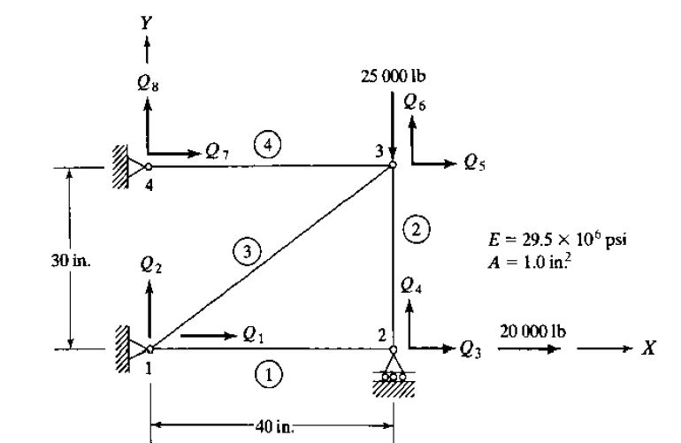

Fig 3.15 Four bar truss element

**Important and Previous JNTUK Questions:**

1.Find deflections at nodes, stresses in members, and reactions at supports for the truss shown in Fig. when the 150-kip load is applied. (Nov SUP 2013, 15M)

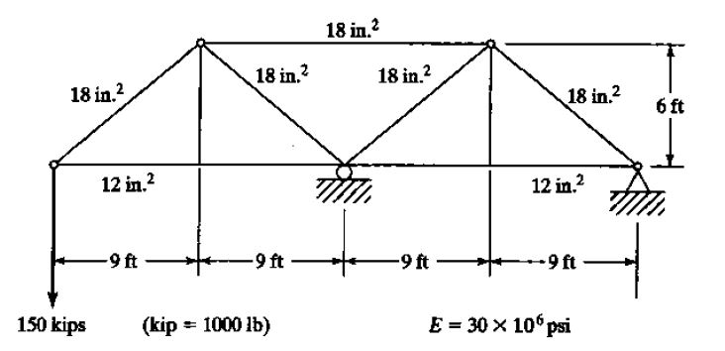

**Fig 3.16**

**Day - 23**

**Concepts Covered:** Element Stiffness Matrix for Hermite Beam Element, Derivation of Load Vector for Concentrated and UDL.

**1.What is a Beam Element? Give some explanation about deformations.**

**Ans:**

Beam is a structural member which is acted upon by a system of external loads perpendicular to axis which causes bending, which means deformation of bar produced by perpendicular load as well as force couples acting in a plane. Beams are the most common type of structural component, particularly in civil and mechanical engineering. A beam is a bar like structural member whose primary function is to support transverse loading and carry it to the supports.

**2.Derive the hermite shape functions for a beam element.**

**Ans:**

Consider a beam of length ‘ L’ with uniform cross section ‘ A’ through out the length as shown in fig.

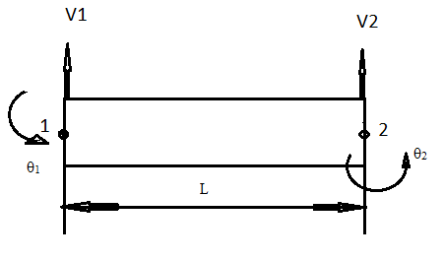

Fig 3.17 Beam element

Since the beam is having two degree of freedom at each node i.e, vertical deflection v and rotation θ. Hence four nodal displacements, so the polynomial equation used should have four polynomial coefficients.

The polynomial function is

V(x) = a1 + a2x + a3x2 + a4x3 --------(1)

V(x) = [ 1 x x2 x3 ] ----------(2)

Applying boundary conditions

At x = 0, v = v1 and = θ1

At x = L, v = v2 and = θ2

= a2 + 2a3x + 3a4x2 ------------(3)

From equations (1) and (3)

v1 = a1

θ1 = a2

v2 = a1 + a2L + a3L2 + a4L3 -----------(4)

θ1 = a2 + 2a3L + 3a4L2 -----------(5)

Writing the above in matrix form we get

{ q } = [ C ] { a } ---------(6)

{ a } = [ C ]-1 { q } ----------(7)

Put equation (7) in (2) we get

V(x) = [ 1 x x2 x3 ] [ C ]-1 { q }

V(x) = [ 1 x x2 x3 ]

V(x) = [ 1 x x2 x3 ]

V(x) =

V(x) =

V(x) = [ N1v1 + N2θ1 + N3v2 + N4θ2 ]

The shape functions are given by

N1 =

N2 =

N3 =

N4 =

The shape functions for beam element are called as hermite shape functions.

**Class work:**

1. Discuss about the deformations in Beams.
2. Derive Hermite shape functions for beams

**Homework:**

1. What is Euler Bernoulli Theory in case of Beam deformations?

**Important and Previous JNTUK Questions:**

1. A fixed beam is loaded with uniformly distributed load of intensity w/m. Assume EI is constant throughout. Analyze the beam by dividing it into two elements and find the following at mid span. (a) Deflection (b) Slope (c) Shear force (d) Bending moment. e) Explain the ways in which a three dimensional problem can be reduced to a two dimensional approach give examples. (NOV 2015, 15M)

**Day - 24**

**Concepts Covered:** Stiffness matrix for beams

**1.Derive the stiffness matrix for beams.**

**Ans:**

To derive the element stiffness matrix for beam element we can use strain energy concept.

The strain energy for a beam element is given by

U = ----------(1)

----------(2)

----------(3)

where F is the nodal force and M is the bending moment and EI is bending rigidity.

σ =

F1 = K11 v1+ K 12θ1 + K13v2 + K14θ2

M1 = K21 v1+ K 22θ1 + K23v2 + K24θ2

F2 = K31 v1+ K 32θ1 + K33v2 + K34θ2

M2 = K41 v1+ K 42θ1 + K43v2 + K44θ2

=

=

=

=

Where,

|  |  |
| --- | --- |
| K11 =  K12 =  K13 =  K14 = | K21 =  K22 =  K23 =  K24 = |
| K31 =  K32 =  K33 =  K34 = | K41 =  K42 =  K43 =  K44 = |

We have N1,N2, N3, N4 are hermite shape functions

N1 = ;

N2 = ;

N3 = ;

N4 = ;

K11 =

K11 =

K11 =

K11 =

K11 =

K11 = 12

Repeat the same procedurefor all K12 to K44

Stiffness matrix for the beam element

[ K ] =

**Stiffness matrix for beam element:**

Consider a beam of length ‘ L’ with uniform cross section ‘ A’ through out the length as shown in fig.

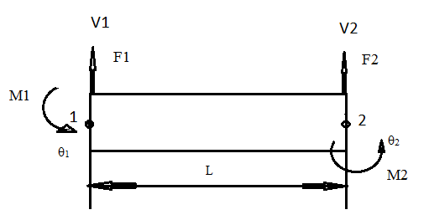

Fig Beam element

Since the beam is having two degree of freedom at each node i.e, vertical deflection v and rotation θ. Hence four nodal displacements, so the polynomial equation used should have four polynomial coefficients.

The polynomial function is

V(x) = a1 + a2x + a3x2 + a4x3 --------(1)

V(x) = [ 1 x x2 x3 ] ----------(2)

Applying boundary conditions

At x = 0, v = v1 and = θ1

At x = L, v = v2 and = θ2

= a2 + 2a3x + 3a4x2 ------------(3)

From equations (1) and (3)

v1 = a1

θ1 = a2

v2 = a1 + a2L + a3L2 + a4L3 -----------(4)

θ1 = a2 + 2a3L + 3a4L2 -----------(5)

Writing the above in matrix form we get

R3 = R3 - R1; R4 = R4 - R2

R3 = R3 - LR2 ; R4 = R4 - R3

R3 = R3 - LR4

R3 = R3 ; R4 = R4

From equation 2 we get,

V(x) = [ 1 x x2 x3 ]

V(x) =

V(x) =

V(x) = [ N1v1 + N2θ1 + N3v2 + N4θ2 ]

Differentiating above equation 3 times

Shear force F = EI ; Bending moment M = EI

To maintain equilibrium condition sum of forces and bending moments should be equal to zero.

Hence ,

F1 = EI ; F2 = EI

M1 = EI ; M2 = EI

At node 1, x = 0

F1 = EI EI] ------(a)

M1 = EI= EI[ -------(b)

At node 2 , x = L

F2 = EI EI]------(c)

M2 = EI = EIEI

M2 = EI

M2 = EI--------- (d)

From equqtions (a),(b),(c),(d) and writing in matrix form we get

**Class work:**

1.Derive the equations of stiffness matrix for a beam element using strain energy concept

**Homework:**

1.Write the expression for stiffness matrix for a beam element

**Day - 25**

**Concepts Covered:** Derivation of load vector for concentrated and uniformly distributed loads.

**1.Derive the load vector for distributed loads.**

**Ans:**

Consider a beam with uniformly distributed load as shown in fig a and b.

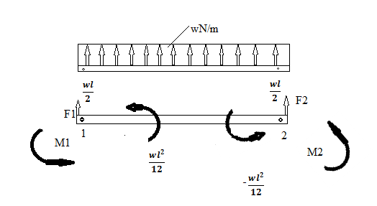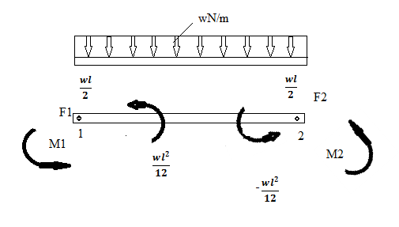

Fig ( a ) Fig ( b )

The governing differential equation for the beam is given by

EI = w ------------(1)

Where,

v – transverse displacement

EI – bending rigidity

w – distributed loading

Integrating the equation ( 1 ) four times we get

EI = wx + C1 ----------(a)

EI = + C1x + C2 ----------(b)

EI = + + C2x + C3 ----------(c)

EIv = + + + C3x + C4 ----------(d)

Where, C1, C2, C3, C4 are coefficients

(slope) ;

EI = M (bending moment );

EI = F Shear force;

Assuming the boundary conditions

At x = 0; v = v1 and θ = θ1

At x = l ; v = v2 and θ = θ2

Substitute the above conditions in equations (c) and (d), we get

EI θ1= C3

EI v1 = C4

EI θ2 = + + C2 + EI θ1 ---------( e)

EI v2 = + + + EI θ1+EI v1 -----------(f)

Equation (e) → + C2 = EI θ2 - - EI θ1 ---------(g)

Equation (f ) → + = EI v2 - - EI θ1 - EI v1 -------(h)

Equation (e)* →

Equation (h - i ) → = EI ( v2 – v1) + - EI θ1 - EI θ2

**Class work:**

1. Write about Hermite Shape Functions?
2. Write in brief about the Beam element forces with its equivalent loads?

**Homework:**

1. What are Bending Moment and Shear Force in Beams?
2. Derive Stiffness Matrix for a Beam Element?

**Important and Previous JNTUK Questions:**

1. What are essential and natural boundary conditions for a beam element? (JUN 2015, 8M)
2. What is Stiffness Matrix for a Beam Element? (JUN 2012, 7M)

**DAY-29**

**Concepts Covered:** *Simple Problems on Beams.*

**Problem1:**

**Homework:**

1. 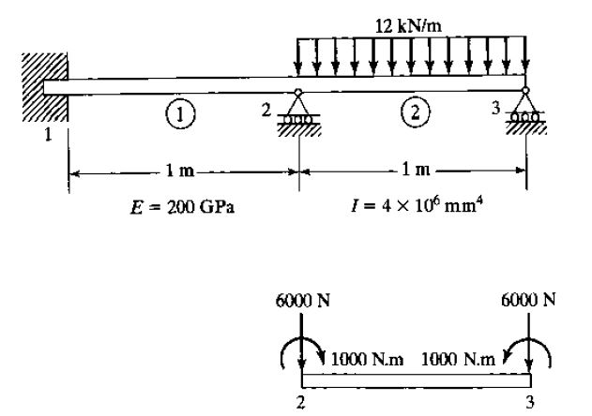For beam and loading shown in Figure. Determine (1) the slopes at 2 and 3 and (2) the vertical deflection at the midpoint of the distributed load.

**Important and Previous JNTUK Questions:**

1. Calculate the deflection at the centre and slopes at the ends of a simply supported beam of 2 m length subjected to a Uniformly Distributed Load (UDL) of 50 kN/m throughout the length. Take EI = 700 Nmm2. (JUN 2015, 8M)
2. 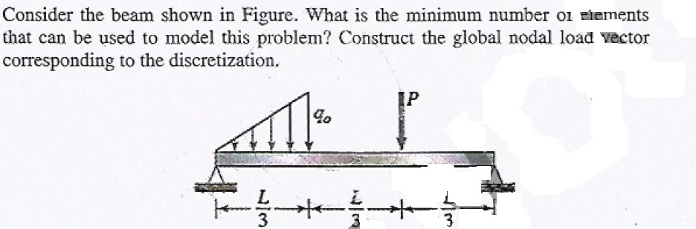Consider the beam shown in figure. What is the minimum number or elements that can be used to model this problem? Construct the global nodal load vector corresponding to the discretization. (NOV 2015-15M)